**3. ReactJS HandsOn**

Create a react app for Student Management Portal named scorecalculatorapp and create a function component named “CalculateScore” which will accept Name, School, Total and goal in order to calculate the average score of a student and display the same.

1. Create a React project named “scorecalculatorapp” type the following command in terminal of Visual studio:



1. Create a new folder under Src folder with the name “Components”. Add a new file named “CalculateScore.js”
2. Type the following code in CalculateScore.js

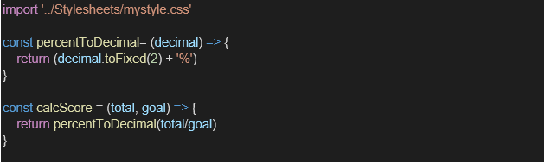

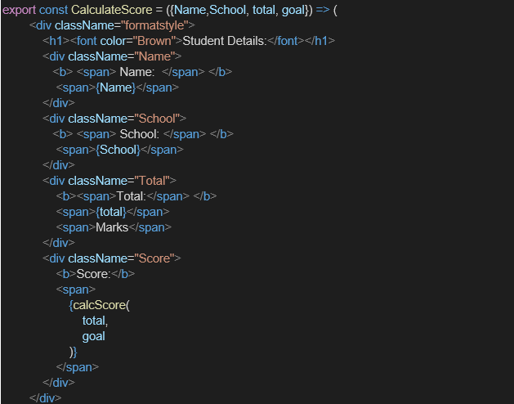

1. Create a Folder named Stylesheets and add a file named “mystyle.css” in order to add some styles to the components:

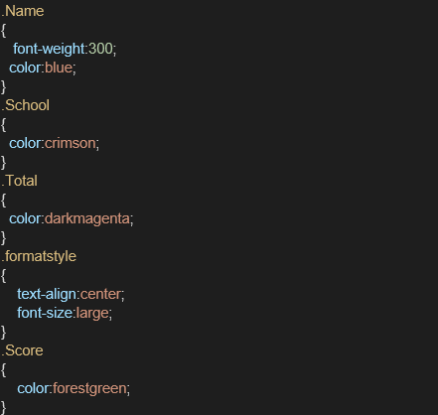

1. Edit the App.js to invoke the CalculateScore functional component as follows:

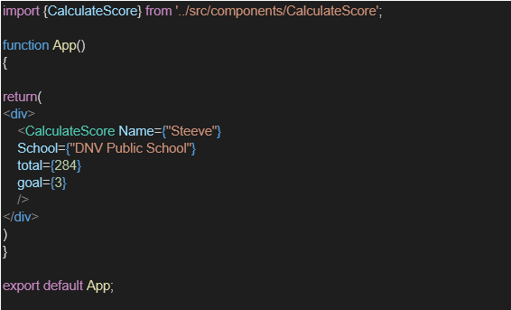

1. In command Prompt, navigate into scorecalculatorapp and execute the code by typing the following command:



**Project Structure**

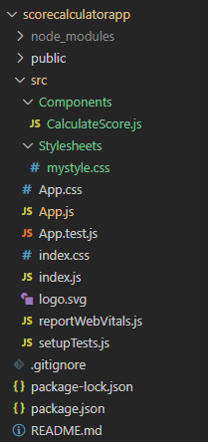

**CalculatorScore.js**

import '../Stylesheets/mystyle.css';

const percentToDecimal = (decimal) => (decimal.toFixed(2) + "%");

const calcScore = (total, goal) => percentToDecimal(total / goal);

export const CalculateScore = ({ Name, School, total, goal }) => (

  <div className="formatstyle">

    <h1><font color="Brown">Student Details:</font></h1>

    <div className="Name">

      <b><span>Name: </span></b>

      <span>{Name}</span>

    </div>

    <div className="School">

      <b><span>School: </span></b>

      <span>{School}</span>

    </div>

    <div className="Total">

      <b><span>Total:</span></b>

      <span>{total}</span>

    </div>

    <div className="Score">

      <b>Score:</b>

      <span>{calcScore(total, goal)}</span>

    </div>

  </div>

);

**mystyle.css**

.Name {

  font-weight: 300;

  color: blue;

}

.School {

  color: crimson;

}

.Total {

  color: darkmagenta;

}

.Score {

  color: forestgreen;

}

.formatstyle {

  text-align: center;

  font-size: large;

}

**App.js**

import { CalculateScore } from './Components/CalculateScore';

function App() {

  return (

    <div>

      <CalculateScore

        Name={"Steeve"}

        School={"DNV Public School"}

        total={284}

        goal={3}

      />

    </div>

  );

}

export default App;

**Output:**

